From www.handoutsonline.com © Handouts Online


!

STUDENT B
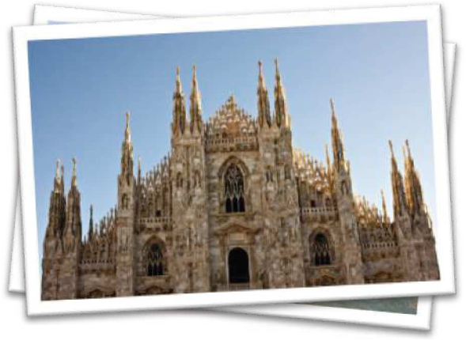

Mr. Sanders went to Italy last month. He stayed there for …………………………….. First, he flew to Rome. He stayed in ………………………….... He really liked the city because it is very historical. On the first day, he visited …………………………... . In the afternoon, he went to Vatican City. He thought St. Peter’s was wonderful.

After Rome, Mr. Sanders went to ………………….... This city was very different from Rome, he thought. He rode a gondola three times.

He took pictures of the ……………………………..... He stayed in a cheap hotel near the Grand Canal. His favorite food was …………………………….. He drank quite a lot of wine!

Finally, Mr. Sanders went to ………………………. . Everyday he went shopping. He bought ……………………….. . On the last day, he went to an art gallery. He sent some postcards to ………………………. .

At Milan Airport, Mr. Sanders bought a lot of duty free goods! He also got ……………………………... for his family.

From www.handoutsonline.com Page 1 PHOTOCOPIABLE
From www.handoutsonline.com © Handouts Online


Write questions.
1. | When | ? |  | He went to Italy last month.
2. | Where | ? |  | He flew to Rome first.
3. |  | ? |  | He liked Rome because it's very historical.
4. |  | ? |  | He went to Venice after Rome.
5. |  | ? |  | He stayed in a cheap hotel.
6. |  | ? |  | He rode a gondola three times.
7. |  | ? |  | He took pictures of the canals.
8. |  | ? |  | His favorite food was pasta.
9. |  | ? |  | He bought some designer goods in Milan.
10. |  | ? |  | He sent postcards to his friends.
11. |  | ? |  | He bought a lot of duty free goods at
 |  |  |  | Milan airport.
12. |  | ? |  | He got some souvenirs for his family.

From www.handoutsonline.com Page 2 PHOTOCOPIABLE

